**SQL Assignment 1**

* 1. select all the rows for the month of April

* 1. distinct number of products, vendors

* 1. sort all the rows by quantity

* 1. select rows where the day of the order is an even number, and the quantity is greater than 10

* 1. select all the rows where the quantity is greater than 10 or the amount is greater than 100

* 1. select rows with order date between May 1 and May 10

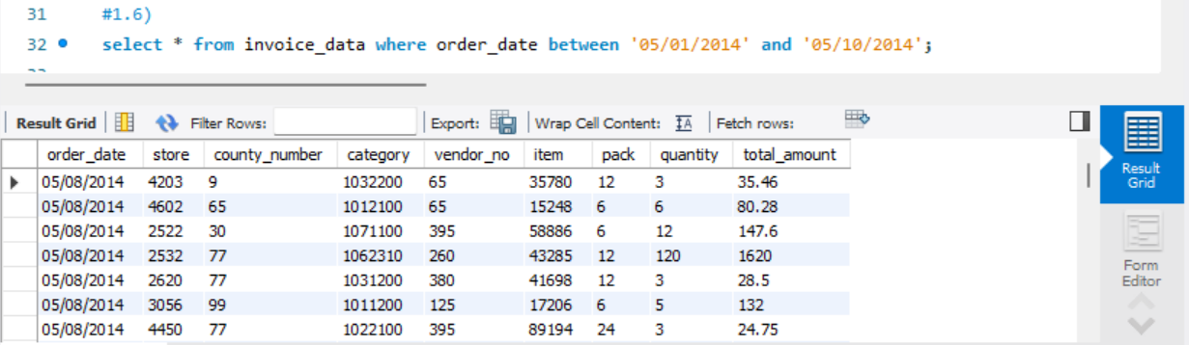

* 1. Sum and Average sales for each product, vendor, category, store

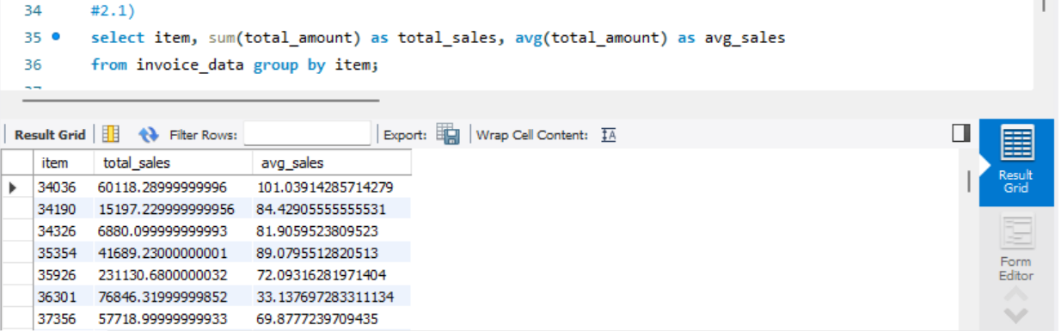

* 1. count of stores that have total sales greater than 1,000

* 1. MoM % Change in Sales and Quantity

* 1. Summary of all the vendors with name containing wine in them

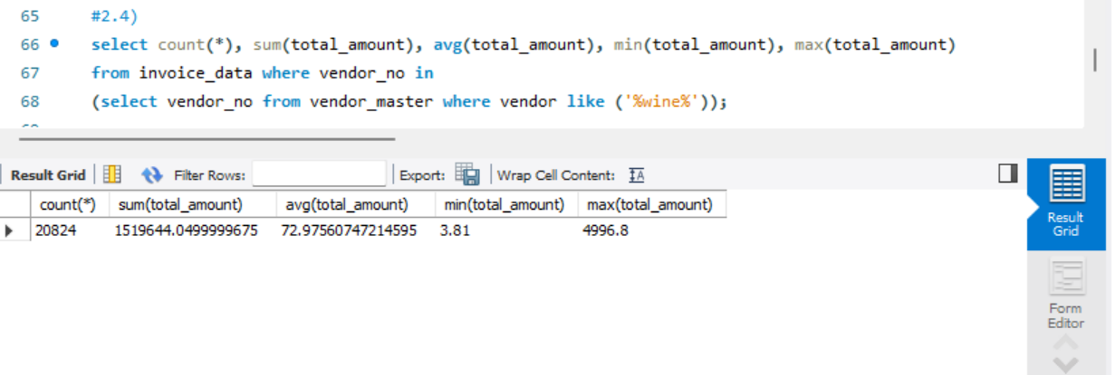

* 1. Sum and Average sales for each product, vendor, category, store

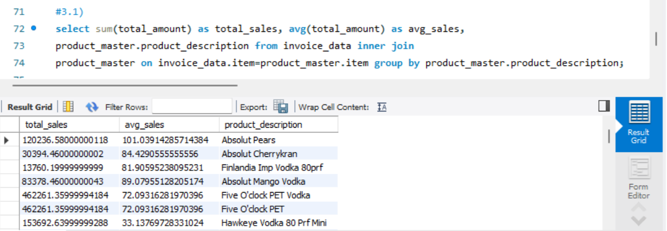

* 1. count of stores that have total sales greater than 1,000

* 1. MoM % Change in Sales and Quantity

* 1. Summary of all the vendors with name containing wine in them

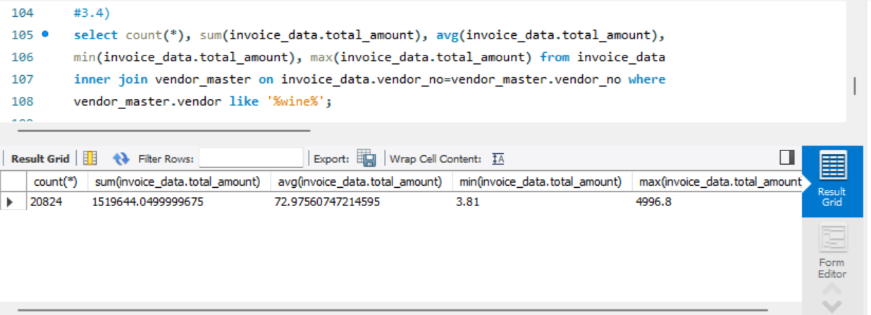

1. Top 5 products with Sales in every Product Category

* 1. Create a table with Product Summary - Product id, Product description, Product Category, Month, Total quantity, and Total Amount

* 1. Create view with Vendor Summary - Vendor id, name, month, total quantity, and total amount

